NAME: KAVITAPU SWARNA VARSHINI
REG.NO: 192324081
DATE: 14-07-2026

write a python program to solve 8 queens’ problem

AIM: To write a Python program to solve the 8-Queens Problem using the Backtracking Algorithm, ensuring that no two queens attack each other.

ALGORITHM:
- Start placing queens row by row on the chessboard.
- Check whether the current position is safe (no queen in the same column or diagonal).
- If the position is safe, place the queen and move to the next row.
- If no safe position is found, backtrack and try another position.
- Repeat until all 8 queens are placed, then display the solution.

CODE:
N = 8
board = [[0] *N for _ in range(N)]
def safe (r, c):
for i in range(r):
if board[i][c]:
return False
i, j = r-1, c-1
while i >= 0 and j >= 0:
if board[i][j]:
return False
i -= 1
j -= 1
i, j = r-1, c+1
while i >= 0 and j < N:
if board[i][j]:
return False
i -= 1
j += 1
return True
def solve(r):
if r == N:
return True
for c in range(N):
if safe (r, c):
board[r][c] = 1
if solve(r+1):
return True
board[r][c] = 0
return False
solve (0)
print("Solution:")
for row in board:
print(row)

OUTPUT:
[1, 0, 0, 0, 0, 0, 0, 0]
[0, 0, 0, 0, 1, 0, 0, 0]
[0, 0, 0, 0, 0, 0, 0, 1]
[0, 0, 0, 0, 0, 1, 0, 0]
[0, 0, 1, 0, 0, 0, 0, 0]
[0, 0, 0, 0, 0, 0, 1, 0]
[0, 1, 0, 0, 0, 0, 0, 0]
[0, 0, 0, 1, 0, 0, 0, 0]

IMAGE:
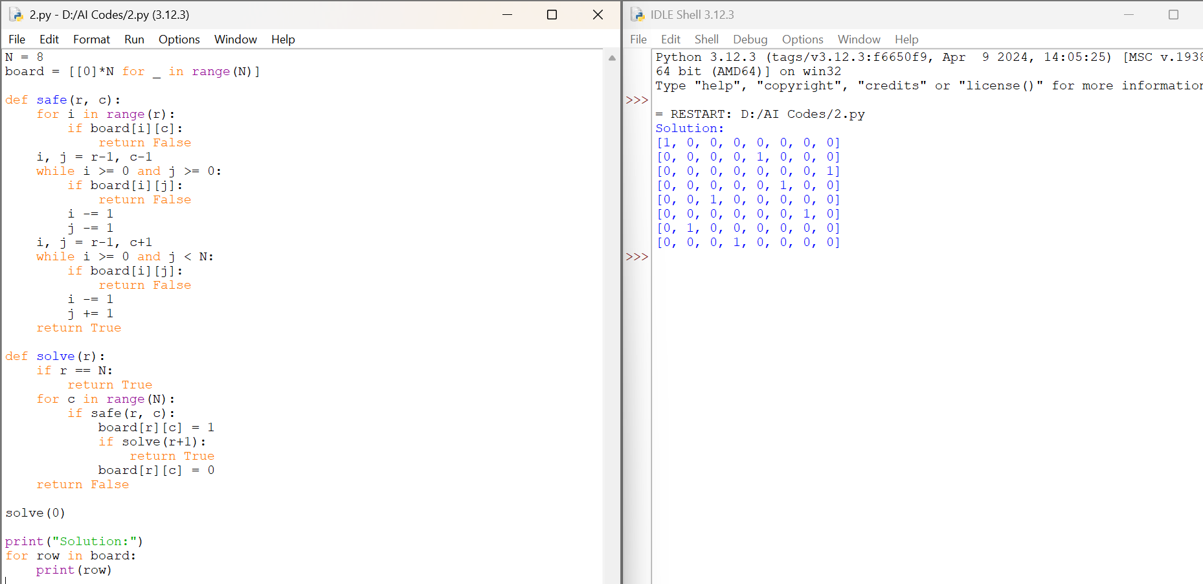

RESULT:
The Python program was executed successfully, and all 8 queens were placed on the chessboard such that no two queens attack each other, using the Backtracking Algorithm.

